The fixed marine risers dynamic analysis with 1st and 5th order rogue wave

Aidin Kazemi Daliri, Sepanta Naimi*

Department of Civil Engineering, Specialty of Coastal Engineering, Istanbul Aydin University, Istanbul, 34295, Turkey.

* Corresponding Author: sepanta.naimi@gmail.com

ABSTRACT

In offshore structures, risers are valuable constituents used in the oil and gas industry. The study of the behaviour of risers in extra critical environmental condition could be contributory to find out the effective economical way to boost up the serviceability life of the structure. To this aim, in this study, a traditional Gas Export Riser, Oil Export Riser and also a Thermoplastic Composite Pipe as a new material in offshore applications are assumed for an offshore jacket located in the North Sea. To simulate the extra critical condition, a Rogue Wave has been considered. Due to the importance of the hydrodynamic interaction effects and dynamic response in offshore structures, the RW has been exerted on the mentioned risers with dynamic analysis in the time domain with using ANSYS software. Two well-known wave theories, the 1st order wave theory and the 5th order wave theory are used and compared for the dynamic analysis. It is shown that for Gas Export Riser and Oil Export Riser, 5th order wave provides less forces on the structure of the offshore jacket in comparison with the 1st order wave. Also Thermoplastic Composite Pipe response to rogue wave affect less the jacket comparing to Gas Export Riser and Oil Export Riser.

Keywords: Dynamic analysis; Riser; Thermoplastic; Offshore jacket; Wave.

INTRODUCTION

Risers are significant constituent in offshore interventions. They are pipes or ducts that furnish a momentary extension of gas or oil to a surface infrastructure such as marine jackets. Offshore risers are usually designed to be fixed or to operate while submerged, according to the structure of the platform (DNV, 2010). Fixed steel jackets are the principal structures commonly utilized in the petroleum industries for low and intermediary water depth (Mirtaheri et al., 2009) in maritime environments. In this investigation, these risers are taken into account. A sample of risers on the jacket structure with various details is shown in Figure 1.
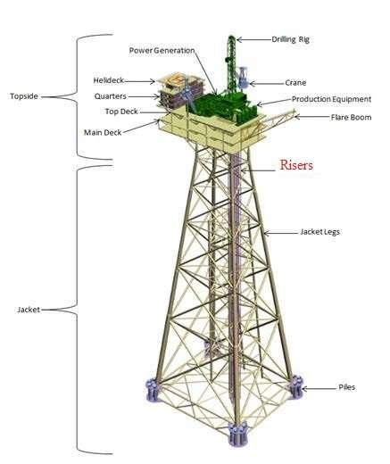

Figure 1. Sample of an offshore jacket’s risers

Risers are usually made by steel. In recent years, alternatives to traditional steel risers in various marine applications have been considered and composite materials as an alternative are introduced in the offshore industries. large researches has been done to consider the usage

of composite risers with notable benefits in the offshore fields such as lightweight, corrosion resistance, high strength, flexibility and affordable maintenance costs (Ochoa et al., 2005, Dalmolen et al., 2009 & Yu et al., 2015). Among different type of composite risers,

Thermoplastic Composite Pipes (TCPs’) are introduced for oil and gas exportation (Van Onna et al., 2012). In this study, TCP has been considered.

Etc………………

Etc………………

To this end, in this study, brief presentations of thermoplastic composite pipes have been done. Then, a little introduction of rogue waves is presented. Afterward, environmental and structural specifications of the jacket have been described. Then with ANSYS software, dynamic analysis has been performed. The goal is to compare displacements and particularly reaction forces of the mentioned risers on the jacket’s deck with using 1st and 5th order (linear and nonlinear) wave theories. Finally, the results have been evaluated.

THERMOPLASTIC COMPOSITE PIPES

As mentioned in Section 1, thermoplastic composite pipes according to their characteristics are a valuable new alternative to steel risers in oil and gas industries. The significant decreases in weight, top tensions and buoyancy requirements compared to traditional steel risers, are remarkable incentives for offshore companies to invest in this new product.

About the construction of these pipes, as shown in Figure 2, these kinds of pipes are made of a liner, thermoplastic composite reinforcement layers and a jacket. All of them are the same thermoplastic polymer materials with fiber reinforcements. As a matter of fact, a solid wall is a support for the pipe in all load situations (Van Onna et al., 2012).

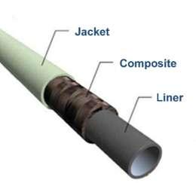

Figure 2. Thermoplastic Composite Pipe (TCP) (Van Onna et al., 2012)

ROGUE WAVES

Rogue waves (RW’s), also recognized as extreme waves, freak waves or killer waves, are large ocean waves considered in extra critical environmental conditions. The appropriate definition of RW is that it manifests casually from nowhere and vanish without any kind of sign. These waves are inclined to grow exponentially and thus have the possibility of rising up to very high amplitudes (N. Akhmadiev et al., 2009 & N. Akhmadiev et al., 2013).

Rogue waves apparently do not have a single reason, but take place where physical considerations like high winds and strong currents cause combinable waves that lead to a single unusual large wave (Rouge Waves, 2009).

Once, RWs’ were being discussed for the lack of proof for their existence, but its scientific measurement was only totally confirmed with the "Draupner wave". A rogue wave impacted to the Draupner platform, in the North Sea on January 1, 1995. During that event, fortunately minor damage was occurred to the platform (Adcock et al., 2011). To give an idea about the intensity of RWs’, the maximum amplitude of Draupner wave is shown in Figure 3.

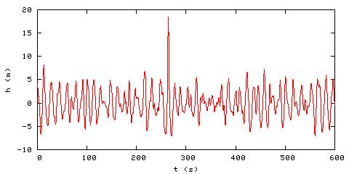

Figure 3. The Draupner rogue wave (Ciceron, 2014).

Currently, there is a general accord on the risks of rogue waves, about the safety of offshore structures. Thus, the consideration of this kind of wave on the marine structure could be really efficient for the analysis and design optimization.

GENERAL ENVIRONMENTAL AND STRUCTURAL SPECIFICATIONS
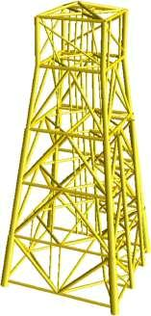

Figure 4. The four leg offshore jacket (Van Raaij & Gudmestad, 2007).

We have considered for the analysis a fixed jacket type platform with four leg tubular steel frame as a 4-pile platform, located in the North Sea as shown in Figure 4. The water depth is
70 m. The 32 inch (0.81 m) Gas Export Riser (GER), 22 inch (0.55 m) Oil Export Riser (OER) and 20 inch (0.50 m) Thermoplastic Composite Pipe (TCP) for oil exportation have been hypothesized for dynamic analysis. They are extending vertically from the seabed to 25.5 m above the sea level until the main deck.

Etc……………

Etc……………

For define which technique to use in the analysis, with the RW’s period mentioned (15 s) the wavelength has been calculated by trial and error with the following equation:

(1)

In Equation 1, g is the acceleration of gravity (9.8 m/s²), d is the water depth (70 m) and

π=3.14. As shown in Table 1, in all cases, the ratio of the calculated wavelength (311 m) to the riser diameter is very large, so the Morison equation is applicable for the analysis (Sorensen, 2006).

Table 1. The ratio of the wavelength (L) to the different riser’s diameter (D).

Riser type | D (m) | L/D
GER | 0.81 | 383
OER | 0.55 | 565
TCP | 0.50 | 622

Usually the concept of the Morison equation is the sum of the drag and inertia forces as follow:

(2)

Where F is the wave load, F_{D} and F_{I}, respectively, are the drag and inertia force (N/m²), ρ is the total density of the sea water (1025 kg/m³), D is the member diameter (m), u and u t respectively are the horizontal water particle velocity (m) and acceleration (m/s²) at the axis of the member. The drag (C_{d}) and inertia (C_{m}) coefficients are 1.05 and 1.2. They have been

selected from American Petroleum Institute (API) standard (API, 2000) with taking into consideration the effect of marine growth on drag and inertia coefficients because over time, marine structures may be covered with marine growth.

MODELING AND ANALYSIS

Modeling and analysis of GER, OER and TCP have been performed with finite element ANSYS software. Element type used for modeling in the software is PIPE 59. This element is being used for the simulation of sea conditions because it is a uniaxial member with tension-compression, torsion, bending and deflection capacities. It is possible to include also the hydrodynamic and a buoyancy effect of water and the element mass includes the added mass of the water and the pipe internals (ANSYS Inc).

Etc………….

Etc………….

About the material properties for steel and thermoplastic composite pipes, data used in the analysis are mentioned in Table 2.

Table 2. Material properties used for GER, OER and TCP.

Material Properties | Steel | Thermoplastic Composite
Density (kg/m³) | 7850 | 1600
Young’s Modulus (GPa) | 210 | 6
Poisson’s Ratio | 0.35 | 0.25

After dynamic analysis in the software, the nodal displacements for different risers, considering linear and nonlinear rogue waves, are presented respectively in Figures 5, 6 and 7. It should be noted that the loading time of the wave is hypothesized to be 100 s.
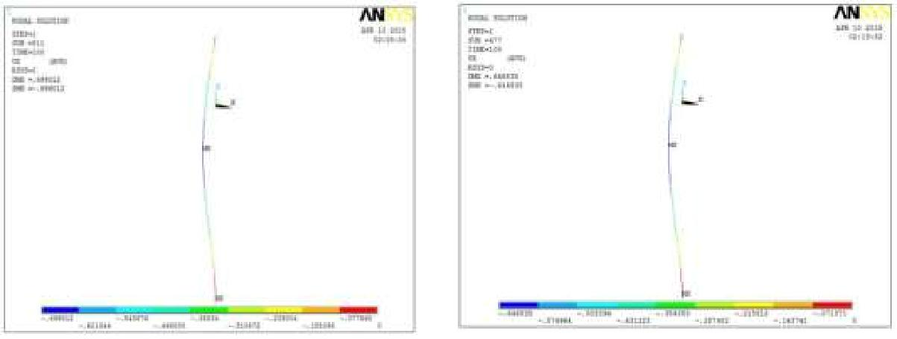

(a) (b)

Figure 5 The GER nodal displacement after dynamic analysis under the effect of 1st order (a) and 5th order (b) RW.
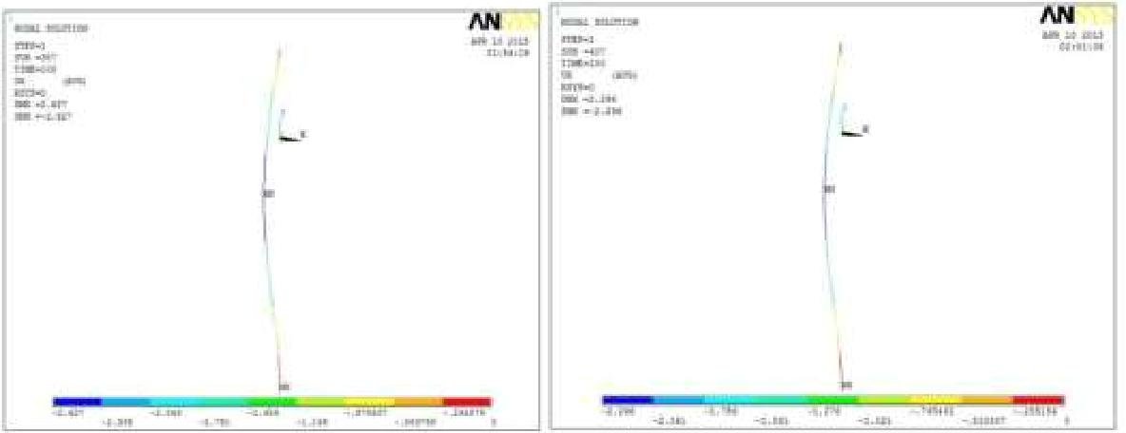

(a) (b)

Figure 6 The OER nodal displacement after dynamic analysis under the effect of 1st order (a) and 5th order (b) RW.
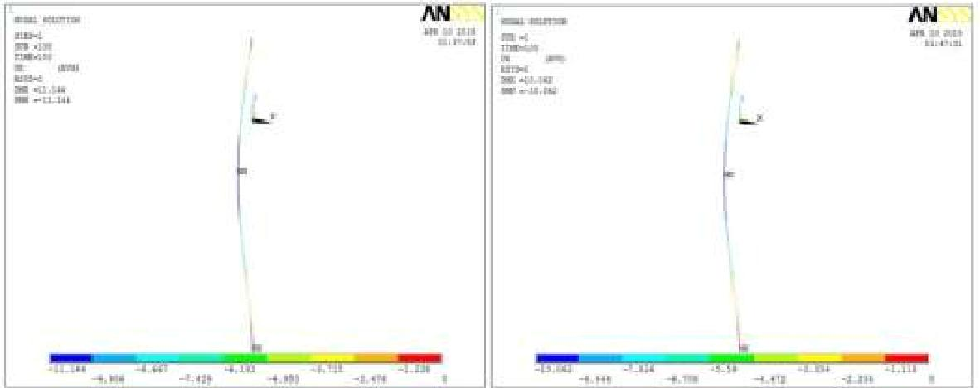

(a) (b)

Figure 7. The TCP nodal displacement after dynamic analysis under the effect of 1st order (a) and 5th order (b) RW.

The maximum reaction force on top of the GER, OER and TCP on the main deck of the

platform, are shown in Figures 8, 9 and 10.
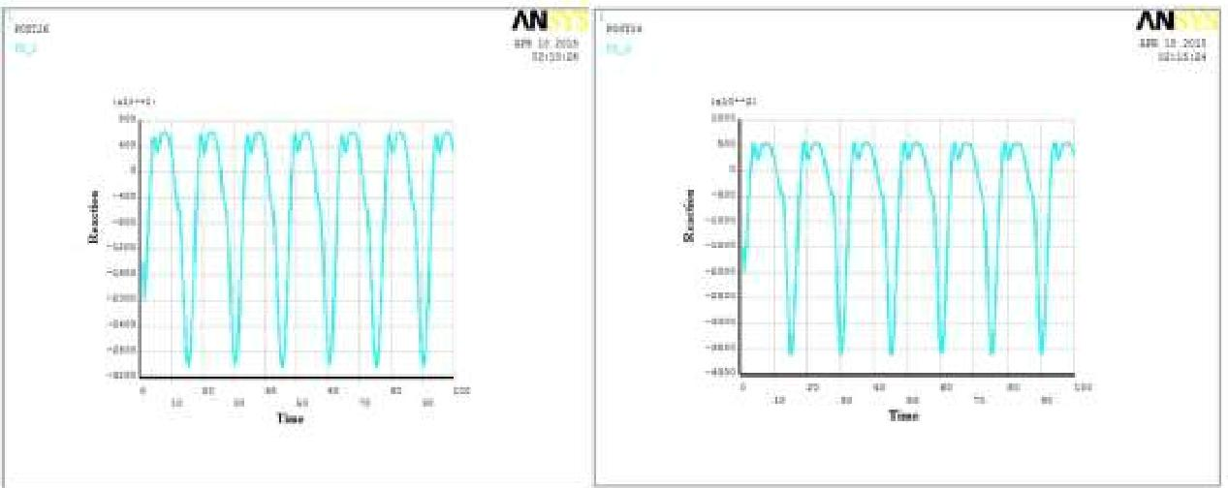

(a) (b)

Figure 8. The time history chart of the reaction force on top of the GER under the effect of 1st order (a) and 5th order (b) RW.
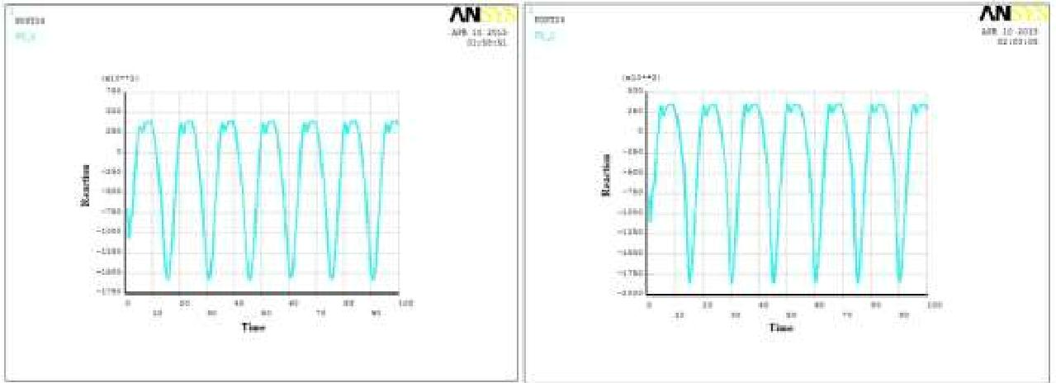

(a) (b)

Figure 9. The time history chart of the reaction force on top of the OER under the effect of 1st order (a) and 5th order (b) RW.

Etc……

Etc……

The general results have been presented in Tables 3, 4 and 5. The 5th order wave theory

provides better results for an economical design of steel risers. About the reaction forces,

Even though the maximum reaction force of the TCP at first place is more than GER and OER, but after t=10 s the reaction force on the deck structure is definitely lower than mentioned risers.

Table 3. Comparison the response to rogue wave for GER

 | 1st order rogue wave | 5th order rogue wave
Maximum Reaction force (KN) on | 63.14 | 57.63
top of the GER
Maximum displacement (m) for | 0.69 | 0.64
GER

Table 4. Comparison the response to rogue wave for OER

 | 1st order rogue wave | 5th order rogue wave
Maximum Reaction force (KN) | 40.08 | 35.42
on top of the OER
Maximum displacement (m) for | 2.6 | 2.29
OER

Table 5. Comparison the response to rogue wave for TCP

 | 1st order rogue wave | 5th order rogue wave
Maximum Reaction force (KN) | 68.15 for t < 10 s | 73.6 for t <10 s
on top of the TCP | 18 for t > 10 s | 20 for t > 10 s
Maximum displacement (m) for | 11.14 | 10.06
TCP
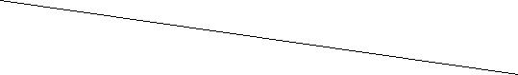

CONCLUSION

In this study, dynamic analysis has been performed on three various risers, GER, OER and

TCP. An extra critical condition has been considered taking into account the 1st order and 5th order wave theory for the analysis. A comparison about the performance of risers on the main deck of an offshore jacket has been implemented.

Etc ……………………….

REFERENCES

DNV, 2010. Offshore Risers Systems, Offshore Service Specifications, DNV-OSS-302.

Mirtaheri, M., Zakeri, H.A., Alanjari, P. & Assareh, M.A. 2009. Effect of joint flexibility on overall behavior of jacket type offshore platforms. American Journal of Engineering and Applied Sceinces.2 (1): 25-30.

Ochoa, O.O. & Salama, M.M., 2005. Offshore composites: transition barriers to an enabling technology. J. Composite Science and Technology 65: 2588–96.

Dalmolen, L.G.P., Kruyer, M.& Cloos, P.J. 2009. Offshore application of reinforced thermoplastic pipe (RTP). Proceedings of the 4th Asian conference and exhibition. Kuala

Lumpur, Malaysia.

Yu, K., Morozov, E.V., Ashraf, M.A.& Shankar, K. 2015. Analysis of flexural behaviour of reinforced thermoplastic pipes considering material nonlinearity. J. Composite Structures 119:385-393.

Van Onna, M., de Kanter, J.& Steuten, B. 2012. Advancements in thermoplastic composite riser development. Proceedings of the ASME 2012 31st International Conference on Ocean, Offshore and Arctic Engineering. Rio de Janeiro, Brazil.

Etc………..

Etc………..

